

|  |
| --- |
| SQL PROJECT  2024 |
| |  | | --- | | PGP DSBA PROGRAM  by: ABHISHEK K HIREMATH | |



|  |  |  |
| --- | --- | --- |
| S NO | Clustering and Cleaning Ads | Page No. |
| 1.1 | Write a query to display customer full name with their title (mr/ms), both first name and last name are in upper case with customer email id, customer creation date and display customer’s category after applying below categorization rules:   1. If customer creation date year <2005 then category a 2. If customer creation date year >=2005 and <2011 then category b 3. If customer creation date year>= 2011 then category c | 3 - 4 |
| 1.2 | Write a query to display the following information for the products, which have not been sold: product_id, product_desc, product_quantity_avail, product_price, inventory values(product_quantity_avail*product price), new_price after applying discount as per the below criteria. Sort the output concerning the decreasing value of inventory_value.   1. If product price > 20,000 then apply 20% discount 2. If product price > 10,000 then apply 15% discount 3. If product price =< 10,000 then apply 10% discount |  |
| 1.3 | Write a query to display product_class_code, product_class_description, count of product type in each product class, and inventory value  (p.product_quantity_avail*p.product_price). Information should be displayed for only those product_class_code that have more than 1,00,000 inventory value. sort the output concerning the decreasing value of inventory_value. | 5 |
| 1.4 | Write a query to display customer_id, full name, customer_email, customer_phone and country of customers who have cancelled all the orders placed by them (use sub-query) | 6 |
| 1.5 | Write a query to display shipper name, city to which it is catering, number of customers catered by the shipper in the city and number of consignments delivered to that city for shipper dhl. | 7 |
| 1.6 | Write a query to display customer id, customer full name, total quantity and total value (quantity*price) shipped where mode of payment is cash and customer last name starts with 'g' |  |
| 1.7 | Write a query to display order_id and volume of biggest order (in terms of volume) that can fit in carton id 10 | 8 – 9 |
| 1.8 | **Write a query to display product_id, product_desc, product_quantity_avail, quantity sold, and show inventory status of products as below as per below condition:**  **a. For electronics and computer categories,**  **i. If sales till date is zero then show 'no sales in past, give discount to reduce inventory',**  **ii. If inventory quantity is less than 10% of quantity sold, show 'low inventory, need to add inventory',**  **iii. If inventory quantity is less than 50% of quantity sold, show 'medium inventory, need to add some inventory',**  **iv. If inventory quantity is more or equal to 50% of quantity sold, show 'sufficient inventory'**  **b. For mobiles and watches categories,**  **i. If sales till date is zero then show 'no sales in past, give discount to reduce inventory',**  **ii. If inventory quantity is less than 20% of quantity sold, show 'low inventory, need to add inventory',**  **iii. If inventory quantity is less than 60% of quantity sold, show 'medium inventory, need to add some inventory',**  **iv. If inventory quantity is more or equal to 60% of quantity sold, show 'sufficient inventory'**  **c. Rest of the categories,**  **i. If sales till date is zero then show 'no sales in past, give discount to reduce inventory',**  **ii. If inventory quantity is less than 30% of quantity sold, show 'low inventory, need to add inventory',**  **iii. If inventory quantity is less than 70% of quantity sold, show 'medium inventory, need to add some inventory',**  **iv. If inventory quantity is more or equal to 70% of quantity sold, show 'sufficient inventory'** | 10 – 11 |
| 1.9 | Write a query to display product_id, product_desc and total quantity of products which are sold together with product id 201 and are not shipped to city Bangalore and new Delhi. Display the output in descending order concerning tot_qty. (use sub-query) | 12 |
| 1.10 | Write a query to display the order_id,customer_id and customer fullname and total quantity of products shipped for order ids which are even and shipped to address where pin code is not starting with "5" | 13 – 14 |

|  |  |  |
| --- | --- | --- |
| S No | Figures and Tables | Page No. |
| 1 | Fig-1: Tables in orders | 5 |
| 2 | **Fig-2:** **Customers details categorized in A, B and C** | 6 |
| 3 | **Fig-3**: **New price table** | 8 |
| 4 | Fig-4: product class above 100,000 | 9 |
| 5 | Fig-5: Cancelled order | 11 |
| 6 | Fig-6: Shipping Details | 12 |
| 8 | Fig-7: Customers paid in cash with last name starts with G | 14 |
| 9 | Fig-8: Total volume | 15 |
| 10 | Fig-9: Inventory Status | 18 |
| 11 | Fig-10: Products sold | 20 |
| 12 | Fig-11: total quantity shipped | 22 |

PROJECT PROBLEM STATEMENT:

You are hired by a chain of online retail stores **“Reliant retail limited”**. They provide you with “**orders**” database and seek answers to the following queries as the results from these queries will help the company in making data-driven decisions that will impact the overall growth of the online retail store.

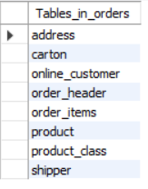

FIG: -1: Tables in orders

Problem 1.

Write a query to display customer full name with their title (mr /ms), both first name and last name are in upper case with customer email id, customer creation date and display customer’s category after applying below categorization rules:

1. **If customer creation date year <2005 then category a**
2. **If customer creation date year >=2005 and <2011 then category b**
3. **If customer creation date year>= 2011 then category c**

**ANSWER:** QUERY EXPLAINATION

1. Column Concatenation (full_name):
   * The CONCAT function combines different values into the single string.
   * The code constructs a full name by concatenating:
     + A salutation (‘Mr/Ms’) based on the customer_creation_date.
     + The uppercase first name (CUSTOMER_FNAME).
     + The uppercase last name (CUSTOMER_LNAME).
   * The resulting column is named full_name.
2. Customer ID (CUSTOMER_ID):
   * This column simply includes the customer ID from the online_customer table.
3. Customer Email (CUSTOMER_EMAIL):
   * Similar to the customer ID, this column will include the email address of each customer.
4. Customer Creation Date (CUSTOMER_CREATION_DATE):
   * The original creation date of the customer is included in the column.
5. Customer Category (customer_category):
   * This column categorizes customers based on their creation date:
     + If the creation date is before 2005, they are in ‘Category A.’
     + If the creation date is between 2005 and 2011, they are in ‘Category B.’
     + Otherwise, they fall into ‘Category C.’

* By assuming when a customer joined, the company can adjust its marketing and customer service strategies. For instance, longtime customers (Category A) might appreciate loyalty rewards, while newer customers (Category C) could be targeted for special introductory offers.

**Marketing segments:**

* The segmented data can help in creating targeted marketing campaigns. Knowing which customers will fall into the which category can allow more personalized and effective promotions.
* Having email addresses alongside other details allows for quick extraction of data for personalized email campaigns aimed at different customer segments.

**Summary:**

The provided query generates a list of customers with their full name, email address, creation date, and their categorized group based on the year of registration. This categorized view is Important for making strategic decisions regarding customer engagement and business growth strategies.

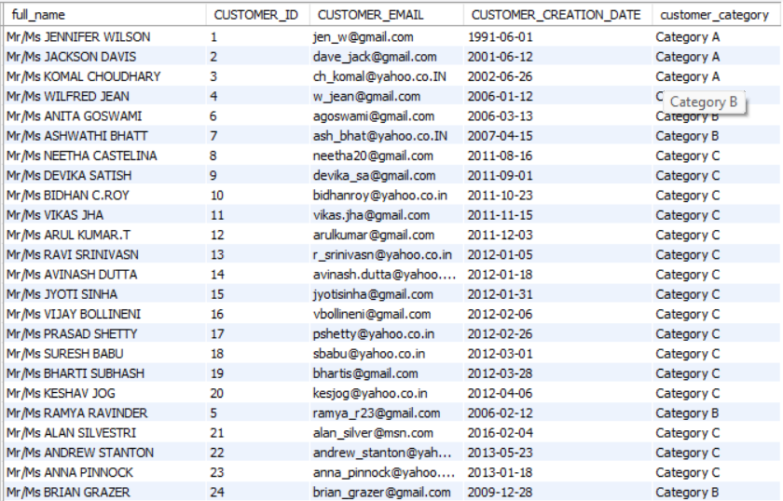

**FIG: - 2: Customers details categorized in A, B and C**

**Problem 2.**

**2. Write a query to display the following information for the products, which have not been sold:  product_id, product_desc, product_quantity_avail, product_price, inventory values(product_quantity_avail*product_price), new_price after applying discount as per the below criteria. Sort the output concerning the decreasing value of inventory_value.**

**i. If product price > 20,000 then apply 20% discount**

**ii. If product price > 10,000 then apply 15% discount**

**iii. If product price =< 10,000 then apply 10% discount**

**ANSWER:** Query Explanation

1. Column Selection:
   * The query selects some columns from product table:
     + product_id: The unique identifier for each product.
     + product_desc: A description of the product.
     + product_quantity_avail: The available quantity of the product in the inventory.
     + product_price: The price of the product.
     + inventory_value: A calculated column representing total value of the product inventory (quantity multiplied by price).
2. Conditional Calculation (new_price):
   * The CASE expression calculates new price based on original product price:
     + If the product price is greater than the 20,000, the new price is 80% of the original price.
     + If the product price is between the 10,000 and 20,000, and the new price is 85% of the original price.
     + Otherwise (product price less than or equal to 10,000), the new price is 90% of the original price.
   * The resulting column named as new_price.
3. Join and Filtering:
   * The query performed a left join between the product table (p) and the order_items table (oi) using the product_id.
   * The WHERE clause filters out rows where there is no corresponding order (i.e., oi.order_id IS NULL).
   * This ensures that only products without any associated orders are included.
4. Ordering Results:
   * The results are ordered by the inventory_value in the descending order.

Inventory Management:

* Helps the business to identify products that are in stock but have not yet been sold. This can prompt further investigation into why these products aren’t moving and what actions can be taken to sell thode.

Giving away Discount:

* The calculated new_price based on different discount provides the business with information on how different pricing strategies can affect the inventory. This helps making strategic discount campaigns to clear out stock.

Marketing and Promotions:

* Knowing the inventory value helps in financial accounting and resource allocation.
* Understanding which products have not sold can guide marketing strategies. For instance, these products could be highlighted in the promotions or sales campaigns to boost their visibility and sales.
* By examining products that remain unsold and their respective inventory values, the business can br better manage storage costs and operational efficiency.

**Summary:**

The provided query lists unsold products along with their descriptions, available quantities, prices, inventory values, and discounted prices. Sorting by inventory value allows the business to prioritize actions on high-value inventory. This information is so important for driving sales, optimizing inventory levels, and improving the company's financial performance.

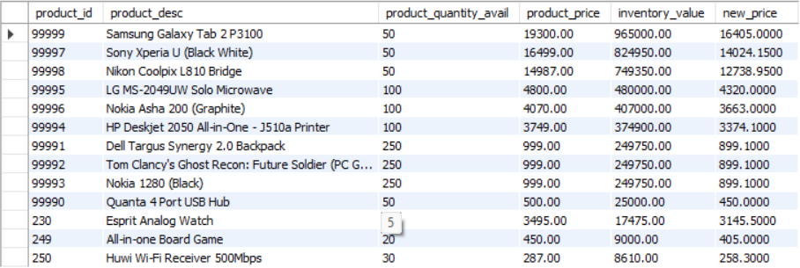

**FIG: -3: New price table**

Here, zero product get 20% discount because none product_decs price is greater than 20,000. Only 3 product_decs get 15% discount and remains gets 10% discount (which are 10 product_decs).

**3. write a query to display product_class_code, product_class_description, count of product type in each product class, and inventory value (p.product_quantity_avail*p.product_price). Information should be displayed for only those product_class_code that have more than 1,00,000 inventory value. sort the output concerning the decreasing value of inventory_value.**

**ANSWER:** Query Explanation

1. Column Selection:
   * The query selects some of columns from two tables: PRODUCT (aliased as p) and PRODUCT_CLASS (aliased as pc).
     + product_class_code: The code representing the product class.
     + product_class_desc: A description of the product class.
     + count_product_type: The count of product types within each class.
     + inventory_value: The total inventory value for each product class (calculated the sum of product_quantity_avail * product_price).
2. Joining Tables (JOIN):
   * The query starts an inner join between PRODUCT and PRODUCT_CLASS tables based on product_class_code.
   * This ensures that we combine information from both tables based on the common product class code.
3. Grouping (GROUP BY):
   * The results are grouped by two the product_class_code and product_class_desc.
   * This means that we’ll have one row per unique product class.
4. Filtering (HAVING):
   * The HAVING clause filters the results to include only those product classes where the inventory_value (total value) is greater than 100,000.
   * This helps focus on significant product classes.
5. Ordering Results (ORDER BY):
   * The results are ordered by inventory_value in descending order.
   * This ensures that the most valuable product classes appear first in the report.

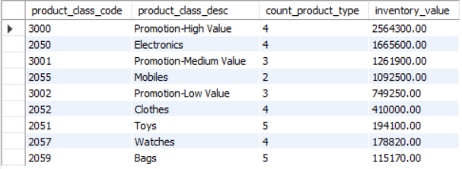

FIG: -4: product class above 100,000

Identifying High-Value products:

* By filtering product classes with inventory values greater than 100,000, the query helps in identifying which product classes has significant inventory value. This is useful for inventory management and financial plans.
* Understanding which product classes have high inventory value can help in strategic decision-making & resource allocation, warehouse space planning, and ensuring that marketing efforts are to promote these high-value products.

Insights:

* High inventory value typically suggests a high potential for sales and revenue. This query can help the business focus on product classes that can significantly impact the company growth.
* By knowing the count of different product type within each high value class, the business can manage stock levels more efficiently, that important items are always available while avoiding overstocking less important items.

**4.Write a query to display customer_id, full name, customer_email, customer_phone and country of customers who have cancelled all the orders placed by them (use sub-query)**

**ANSWER:** Query Explanation

1. Column Selection:
   * The query selects some columns from two tables: online_customer (aliased as oc) and address (aliased as a).
     + customer_id: The unique identifier for each customer.
     + full_name: A concatenated column representing the full name of the customer (first name and last name).
     + customer_email: The email address of each customer.
     + customer_phone: The phone number of each customer.
     + country: The country associated with the customer’s address.
2. Joining Tables (JOIN):
   * The query does an inner join between the online_customer and address tables based on the address_id.
   * This ensures that we combine information from both tables related to customer data.
3. Filtering (WHERE):
   * The WHERE clause filters the results to include only those customers whose customer_id appears in a subquery.
   * The subquery retrieves customer_id values from the order_header table where the order status is ‘Cancelled’.
   * The HAVING clause ensures that only customers with the same count of cancelled orders as their total order count are included.

Customer Service:

* Proactively reaching out to understand the reasons behind the cancellations.
* Improving the customer experience to retain these customers.

Sales and Marketing:

* Identifying important areas for improving in product offer or delivery services.
* Tailoring future marketing strategies to regain their business.
* Streamlining processes to minimize order cancellations and their associated costs.



**FIG: -5: Cancelled order**

This SQL query retrieves customer data, including full names, emails, phone numbers, and associated countries, specifically for customers with only cancelled orders. The customer has canceled the order

**5. Write a query to display shipper name, city to which it is catering, number of customers catered by the shipper in the city and number of consignments delivered to that city for shipper dhl.**

**ANSWER:** Query Explanation

1. Column Selection:
   * The query selects several columns from different tables:
     + shipper_name: The name of the shipping company (in this case, ‘DHL’).
     + city_catering: The city associated with the catering service (from the address table).
     + num_customers_catered: The count of distinct customer IDs served by DHL in each city.
     + num_consignments_delivered: The total number of consignments delivered by DHL in each city.
2. Joining Tables (JOIN):
   * The query does multiple joins to combine data from different tables:
     + shipper (aliased as s) with order_header (aliased as oh) based on the shipper ID.
     + order_header with online_customer (aliased as oc) based on the customer ID.
     + online_customer with address (aliased as a) based on the address ID.
   * These joins allow us to link information about shipments, customers, and their addresses.
3. Filtering (WHERE):
   * The WHERE clause restricts the results to only those rows where the shipper’s name is ‘DHL’.
   * We’re interested in DHL’s performance specifically.
4. Grouping Results (GROUP BY):
   * The results are grouped by shipper_name and city_catering.
   * This grouping helps aggregate data for each city where DHL operates.

Customer Service:

* Measures the working way of DHL in delivering consignments to various cities.
* Determines the effectiveness of DHL coverage and service in different regions.
* Highlights the number of customers served by DHL in each city, which can be useful for assessing customer satisfaction and identifying areas needing improvement.

Strategic Decision Making:

* Provides insights into cities with higher demand for DHL services, allowing better planning and allocation of resources.
* Helps in making dedecisions about continuing, expanding, or changing shipping providers in certain areas based on performance.
* Can be used to identify cities where there might be challenges in delivery and find out reasons for any inefficiencies.

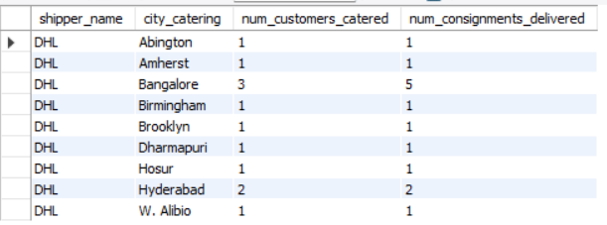

**FIG: -6: Shipping Details**

This query helps Reliant Retail Limited analyze and improve its shipping operations, catering to growing demands in specific areas, and enhances overall customer satisfaction through reliable and efficient delivery services by understanding the contribution and reach of DHL.

**6. Write a query to display customer id, customer full name, total quantity and total value (quantity*price) shipped where mode of payment is cash and customer last name starts with 'g'.**

**ANSWER:** Query Explanation

1. Column Selection:
   * The query selects some of columns from different tables:
     + customer_id: The unique identifier for each customer.
     + full_name: A concated column represent the full name of the customer (first name and last name).
     + total_quantity: The total quantity of products orderes by each customer.
     + total_value: The total value of product ordered by each customer (calculated as the sum of product quantity multiplied by product price).
2. Joining Tables (JOIN):
   * The query doesa multiple joins to combine data from different tables:
     + online_customer (aliased as oc) with order_header (aliased as oh) based on the customer ID.
     + order_header with order_items (aliased as oi) based on the order ID.
     + order_items with product (aliased as p) based on the product ID.
   * These joins allow us to link information about customers, orders, and products.
3. Filtering (WHERE):
   * The WHERE clause stops the results to only those rows where the payment mode is ‘Cash’ and the customer’s last name starts with ‘G’.
   * We’re interested in analyze cash transactions for customer with last names beginning with ‘G’.
4. Grouping Results (GROUP BY):
   * The results are grouped by customer_id, CUSTOMER_FNAME, and CUSTOMER_LNAME.
   * This grouping helps aggregate data for each customer.

Sales Performance:

* Understand purchasing behavior and value brought in by a specific segment of the customer base.
* Evaluate sales performance by identifying which of these customers are high volume buyers in terms of quantity and value.

Payment Mode Analysis:

* Analyze the total business done in cash payments, particularly by customers with last names starting with 'G'.
* Targeted marketing campaigns or promotions for this specific group, especially if they represent a significant portion of sales.

Customer Service:

* Increase relationships with these customers by allowing them to pay their preferred payment method and implement services to meet their needs.
* Helps in managing inventory and understanding demand patterns from a particular group of customers.

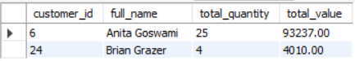

**FIG: -7: Customers paid in cash with last name starts with G**

This query aids Reliant Retail Limited in understanding and assessing the purchasing behavior of a specific customer segment, facilitating more informed decision-making and targeted strategies to enhance customer satisfaction and increase sales. Anita Goswami and Brain Grazer are the two customers who’s having high total_value and total quantity

**7. Write a query to display order_id and volume of biggest order (in terms of volume) that can fit in carton id 10.**

**ANSWER:** Query Explanation

1. Column Selection:
   * The query selects two columns:
     + order_id: The unique identifier for each order.
     + total_volume: A calculated value representing the total volume of products in the order. It will be computed by multiplying the product quantity (oi.product_quantity) with the dimensions (LEN, WIDTH, and HEIGHT) of the associated carton.
2. Joining Tables (JOIN):
   * The query does three joins to combine data from different tables:
     + order_items (aliased as oi) with product (aliased as p) based on the product ID.
     + product with carton (aliased as c) based on the carton ID.
     + This join allows us to link information about orders, products, and cartons.
3. Filtering (WHERE):
   * The WHERE clause restricts the results to only those rows where the order_id appears in a subquery.
   * The subquery retrieves order_id values from the order_items table where the carton_id is 10.
   * This ensures that we’re considering only orders associated with carton ID 10.
4. Grouping Results (GROUP BY):
   * The results are grouped by order_id.
   * This grouping helps aggregate data for each order.
5. Ordering Results (ORDER BY and LIMIT):
   * The results are ordered by total_volume in descending order.
   * The LIMIT 1 ensures that only the order with the highest total volume is returned.

Inventory and Logistics and Shipping**:**

* Helps in optimizing packaging processes by understanding the maximum volume that can fit into a specific carton size.
* Useful for determining appropriate packaging strategies for large orders.
* Assists in planning for shipping logistics by identifying orders that may require special handling or larger shipping containers.
* Helps in identifying high volume orders that could impact shipping costs and logistics planning.
* Aids in efficient resource allocation for packaging materials based on order volume.
* Ensures that the warehouse staff is better prepared to handle large volume orders.

Customer Service:

* Allows for better tracking of large orders to know they are kept safe and delivered correctly, which can improve customer satisfaction.
* Provides insights into the types of products and volumes being ordered, which can guide future inventory and packaging decisions.



**FIG: -8: Total volume**

This order id has the highest total volume

**8. Write a query to display product_id, product_desc, product_quantity_avail, quantity sold, and show inventory status of products as below as per below condition:**

**a. For electronics and computer categories,**

**i. If sales till date is zero then show 'no sales in past, give discount to reduce inventory',**

**ii. If inventory quantity is less than 10% of quantity sold, show 'low inventory, need to add inventory',**

**iii. If inventory quantity is less than 50% of quantity sold, show 'medium inventory, need to add some inventory',**

**iv. If inventory quantity is more or equal to 50% of quantity sold, show 'sufficient inventory'**

**b. For mobiles and watches categories,**

**i. If sales till date is zero then show 'no sales in past, give discount to reduce inventory',**

**ii. If inventory quantity is less than 20% of quantity sold, show 'low inventory, need to add inventory',**

**iii. If inventory quantity is less than 60% of quantity sold, show 'medium inventory, need to add some inventory',**

**iv. If inventory quantity is more or equal to 60% of quantity sold, show 'sufficient inventory'**

**c. Rest of the categories,**

**i. If sales till date is zero then show 'no sales in past, give discount to reduce inventory',**

**ii. If inventory quantity is less than 30% of quantity sold, show 'low inventory, need to add inventory',**

**iii. If inventory quantity is less than 70% of quantity sold, show 'medium inventory, need to add some inventory',**

**iv. If inventory quantity is more or equal to 70% of quantity sold, show 'sufficient inventory'**

**ANSWER:** Query Explanation

1. Column Selection:
   * The query selects several columns from different tables:
     + PRODUCT_ID: The unique identifier for each product.
     + PRODUCT_DESC: A description of the product.
     + PRODUCT_QUANTITY_AVAIL: The available quantity of the product in inventory.
     + product_quantity_sold: The total quantity of the product sold (or 0 if no sales).
     + inventory_status: A calculated column indicating the inventory status based on sales and available quantity.
2. Joining Tables (JOIN):
   * The query joins the product table (aliased as p) with the product_class table (aliased as pc) based on the product class code.
   * This allows us to link information about products and their corresponding classes.
3. Left Join (LEFT JOIN):
   * The query performs a left join with a subquery:
     + The subquery calculates the total quantity sold for each product using the order_items table.
     + The left join ensures that even if there are no sales for a product, it still appears in the report with a quantity sold of 0.
4. Inventory Status (CASE Expressions):
   * The CASE expressions determine the inventory status based on the product class and available quantity:
     + For product classes ‘Electronics’ and ‘Computer’:
       - If no sales, recommend giving a discount to reduce inventory.
       - If low inventory (less than 10% of sales), suggest adding inventory.
       - If medium inventory (less than 50% of sales), recommend adding some inventory.
       - Otherwise, consider inventory sufficient.
     + Similar rules apply for other product classes (‘Mobiles’, ‘Watches’, and others).

Sales, Inventory Balance and Inventory Actions:

* Provides a comprehensive overview of both available quantities and sold quantities of each product.
* Recommends specific actions depending on the sales history and inventory levels:
* For products with no sales Suggests discounts to clear inventory.
* For products with low or medium inventory Indicates the importance to add inventory.
* For products with sufficient inventory Marks them as sufficiently stocked.

Inventory Management:

* Customizes the inventory status evaluation based on product categories:
* Electronics and Computer products require higher inventory edges for actions.
* Mobiles and Watches have slightly lower beginnings.
* Enables proactive decision-making to maintain adequate stock levels.
* Helps in preventing overstock or understock situations in the warehouse.
* Supports planning for promotional activities for non-performing inventory.
* Enhances operational efficiency by providing clear actions to be taken for different products.
* Facilitates collaboration between sales, marketing, and inventory management teams to align strategies with actual data.

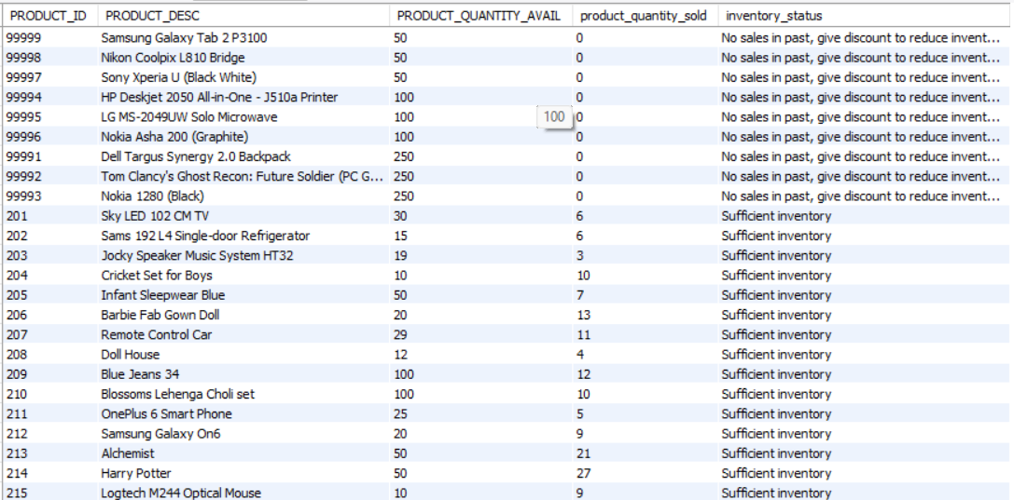

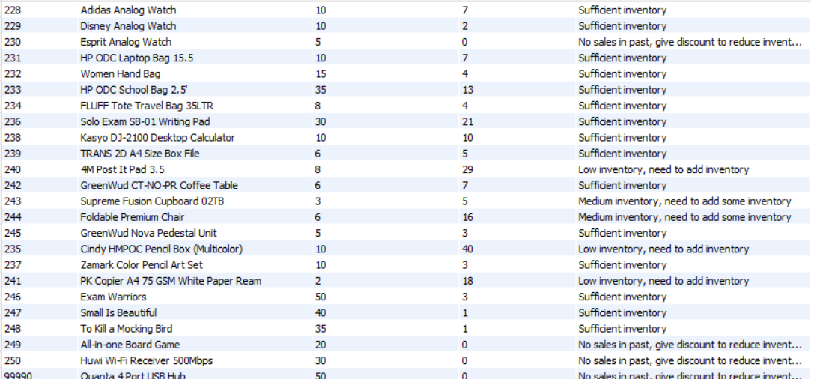

**FIG: -9: Inventory Status**

**9. Write a query to display product_id, product_desc and total quantity of products which are sold together with product id 201 and are not shipped to city Bangalore and new Delhi. Display the output in descending order concerning tot_qty. (use sub-query)**

**Answer:** Query Explanation

1. Column Selection:
   * The query selects three columns:
     + PRODUCT_ID: The unique identifier for each product.
     + PRODUCT_DESC: A description of the product.
     + tot_qty: The total quantity of the product ordered across different orders.
2. Joining Tables (JOIN):
   * The query performs a join between the order_items table (aliased as oi) and the product table (aliased as p) based on the product ID.
   * This allows us to link information about products and their corresponding order items.
3. Filtering (WHERE):
   * The WHERE clause restricts the results to only those rows where the order ID appears in a subquery.
   * The subquery retrieves order IDs from the order_header table based on specific conditions related to customer addresses (excluding Bangalore and New Delhi).
4. Additional Filtering (AND):
   * The query further filters out rows where the product ID is not equal to 201.
   * This ensures that product 201 is excluded from the report.
5. Grouping Results (GROUP BY):
   * The results are grouped by PRODUCT_ID and PRODUCT_DESC.
   * This grouping helps aggregate data for each product.
6. Ordering Results (ORDER BY):
   * The results are ordered by tot_qty (total quantity) in descending order.
   * This arranges the products based on their overall quantity ordered.

Targeted Marketing and Promotions:

* Identifies which products are frequently purchased together with the specific product (product ID 201), but not in 'Bangalore' or 'New Delhi'.
* Allows the marketing team to create targeted promotions for products often bought together with item 201.
* Helps in modifying marketing campaigns for customers not located in 'Bangalore' or 'New Delhi'.

Inventory Management:

* Provides information on the demand for products associated with item 201, helping in better inventory planning and stock management.
* Confirms popular items are effectively stocked in regions other than 'Bangalore' and 'New Delhi'.
* Supports strategic decisions for cross-selling and upselling by leveraging products that are commonly sold together.
* Helps in identifying likely bundles or packages to increase average order value.
* Provides insights allowing for efficient resource allocation in logistics and warehousing.
* Helps in optimizing supply chain operations to focus on regions with higher sales of associated products.

Customer Insights:

* Increases customer experience by understanding and get ahead their needs based on purchasing patterns.
* Allows for better segmentation and personalization of offers based on customer location and buying habits.

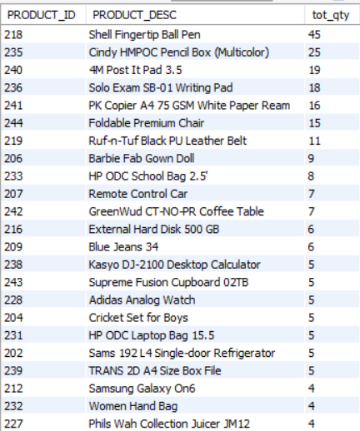

**FIG: -10: Products sold**

* Top-Selling Products: Identify products with the highest total quantities sold. For example, the Shell Fingertip Ball Pen and Cindy HMPOC Pencil Box have high quantities.
* Product Categories: Group products into categories like office supplies, electronics, clothing, and miscellaneous items to analyze sales trends within each category.
* Monitor stock levels for high-demand products to ensure timely restocking and avoid stockouts.
* Evaluate the pricing of products to ensure competitiveness and profitability.

**10. Write a query to display the order_id, customer_id and customer fullname and total quantity of products shipped for order ids which are even and shipped to address where pin code is not starting with "5".**

**ANSWER:** Query Explanation

1. Column Selection:
   * The query selects several columns:
     + ORDER_ID: The unique identifier for each order.
     + CUSTOMER_ID: The unique identifier for each customer.
     + full_name: A concatenated column representing the full name of the customer (first name and last name).
     + total_quantity_shipped: The total quantity of products shipped in each order.
2. Joining Tables (JOIN):
   * The query performs multiple joins to combine data from different tables:
     + order_header (aliased as oh) with online_customer (aliased as oc) based on the customer ID.
     + online_customer with address (aliased as a) based on the address ID.
     + order_items (aliased as oi) with order_header based on the order ID.
   * These joins allow us to link information about orders, customers, and their addresses.
3. Filtering (WHERE):
   * The WHERE clause restricts the results to only those rows where:
     + The order ID is even (i.e., oh.ORDER_ID % 2 = 0).
     + The PIN code (from the address) does not start with ‘5’ (i.e., NOT (a.PINCODE LIKE '5%')).
   * This filters out specific orders and addresses based on the given conditions.
4. Grouping Results (GROUP BY):
   * The results are grouped by ORDER_ID, CUSTOMER_ID, and full_name.
   * This grouping helps aggregate data for each order and customer.

**Customer Analysis:**

* Identifies even-numbered orders, which can be useful for batch processing or targeting specific order sets.
* Helps in separating orders based on a specific sequence (even order IDs).
* Provides detailed information about customers who placed these even-numbered orders.
* Excludes orders to addresses where the pincode starts with '5', which may signify a particular region.
* Helps in focusing analysis on orders outside of this specific geographical area.
* Useful for regional performance analysis, logistics planning, and targeted marketing campaigns.

Strategic Decisions:

* Calculates total quantities shipped per order, aiding in logistics and inventory management.
* Insights gathered can help in determining the load per batch, planning shipping resources, and managing warehouse operations.
* Facilitates efficient resource allocation and improves operational workflows.
* Data can support strategic decisions related to customer service, warehousing, and distribution.
* Helps in identifying patterns or trends in orders that can be leveraged for business improvement.

Targeted Customer Service:

* Enables customer service teams to quickly access necessary information for any inquiries related to these specific orders.
* Enhances customer satisfaction by providing timely and accurate responses.

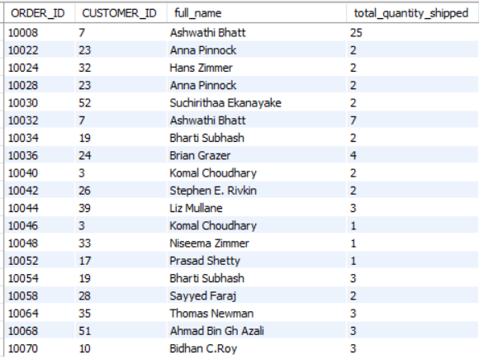

**Fig: -11: total quantity shipped**

* Identify customers with the highest total quantity shipped. For example, Ashwathi Bhatt and Bharti Subhash have multiple orders with significant quantities.
* Analyze how frequently each customer places orders. Customers like Anna Pinnock and Komal Choudhary have multiple entries, indicating regular transactions.
* Evaluate the total quantity shipped per order. Orders range from 1 to 7 units, which can help in understanding demand patterns.